Grant Information
Grant Name: Soil Health Management Systems for Orchards in California’s Central Valley
Awarded By: Natural Resources Conservation Service – Conservation Innovation Grant On-Farm Trials
PROJECT BACKGROUND
Federal, state, and local agencies, in addition to market-driven demand, have contributed to increased interest in the application of practices beneficial to soil in order to address on-farm issues such as water quality, nutrient management, and pest control. Several partners including American Farmland Trust, California Alliance for Family Farms, Project Apis m, and other RCDs have started on-farm trials to demonstrate that conservation practices implemented through the utilization of comprehensive soil heath management systems can aptly address these and a multitude of other issues.
This project will be headed by the East Stanislaus Resource Conservation District (ESRCD) and will include a total of 35 orchards within Fresno, Madera, Merced, Stanislaus, San Joaquin, Kern, Kings and Tulare counties to conduct whole orchard management system trials in a five-year study. This comprehensive study includes the evaluation of soil health management systems, economic outcomes and social outcomes within Trial and Control sites, providing much needed data to address California’s water insecurity, ultimately providing solutions to our state’s crisis.
NRCS ELIGIBLE PRACTICES

Whole Orchard Management Systems address the entire orchard, not just the trees, through focusing on a combination of soil health practices specific to that orchard. NRCS soil health practices can be combined and include, but are not limited to:

+ Cover cropping + Compost application + Hedgerows
+ Reduced tillage/no-till + Pollinator strip + Windbreak/shelterbelts
+ Riparian restoration + Nutrient management + Irrigation evaluations

PARTNERING AGENCIES

ESRCD’s staff includes a Project Coordinator, Soil Health Coordinator and Conservation Planner who will be working with key regional partners to implement a full evaluation of the program outcomes. Partners include the University of California, Merced for soil laboratory analysis, American Farmland Trust for economic outcomes and data collection, Community Alliance with Family Farmers for social outcomes and program outreach, and Project Apis m. for technical assistance for cover crop planning, implementation and maintenance.

PROJECT TIMELINE

+ Application Window: Every December until 2024
+ Site Visit: Starting in Feb
+ Project Selection: Spring 2023
+ Verification of NRCS EQIP Eligibility: Spring 2023
+ Projects Implemented: Starting Fall 2023 – Spring 2025

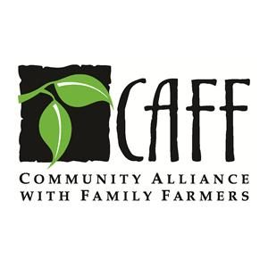
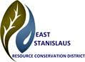
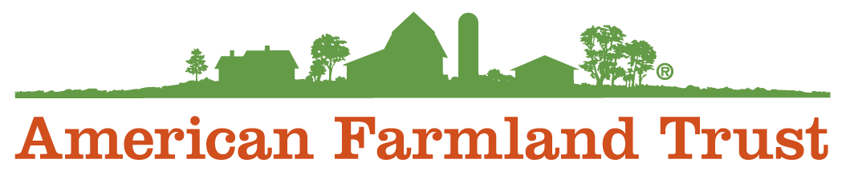
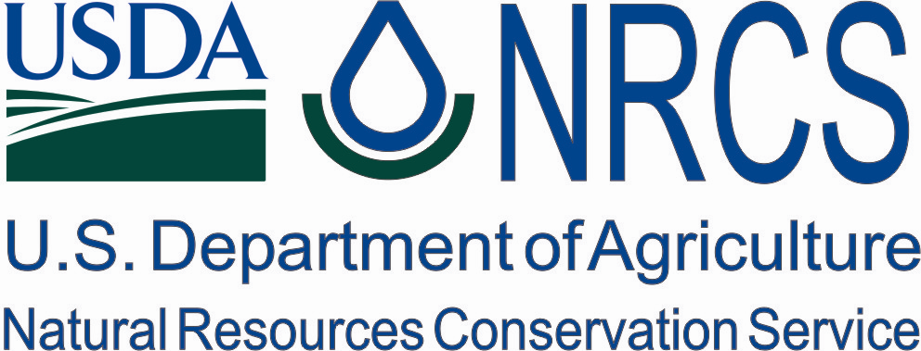

Landowner Application Form
PERSONAL INFORMATION

First Name: Last Name:
Mailing Address:
Phone #: Email:
Are you a veteran, Native American, woman, or person of color? (optional)

PROPERTY INFORMATION

Property Address: County:
Parcel/s # (APN) & Acreage:
Type of Orchard (almonds, walnuts, etc.):
Are you able to provide 25% of the cost of implementation?

Have you registered with Farm Service Agency for eligibility to apply for USDA programs? (See the eligibility requirements listed below) ◻ Yes ◻ No ◻ Not sure

By signing after the following statement, I am stating that at all landowners/lessees are aware of and are agreeable to participate in all of the steps of the program. The program includes working with and allowing project access upon prior consent to staff of the East Stanislaus Resource Conservation District and all partner organizations identified on the application form. All landowners and lessees have reviewed the project application and are ready to proceed with project selection.

Applicant Signature Date

Eligibility Checklist

TO APPLY, PLEASE MAKE SURE TO COMPLETE THIS CHECKLIST:

◻ My orchard is in Fresno, Madera, Merced, Stanislaus or San Joaquin, Kern, Kings OR Tulare county
◻ I have completed the Landowner Application Form & SIGNED it
◻ I have attached a map to my application
◻ I have scheduled a SITE VISIT
◻ I will be NRCS-EQIP eligible with the Farm Service Agency at the start of the project, which includes the submission of these documents:
◻ CA-LTP-5 Irrigation History
◻ CCC-941 AGI (Adjusted Gross Income) Certification for 2020
◻ AD-1026 Highly Erodible Land Conservation and Wetland Conservation Certification
◻ Land Control (lease or deed)
◻ CCC-901A Members Information
◻ For an Inc-Corporation Papers (By-laws or Operating Agreement & Articles of Incorporation)
◻ For any other Entity-Partnership Papers (Partnership Agreements including formation date, signature authority & current list of partners with share percentages, etc.)
◻ If any members of the above are members as a Trust or applying as a Trust-Trust Documents (Trust name, formation date, Trustor/Trustee information, signature authority and current list of beneficiaries with share percentages, etc.)
◻ FSA-211 Power of Attorney, if applicable

TO SUBMIT YOUR APPLICATION:

Please submit the Landowner Application Form + Eligibility Checklist, including a map of existing infrastructure via email, mail or fax to:

Mailing Address: Attn: Andrea Brophy
East Stanislaus Resource Conservation District
3800 Cornucopia Way, Suite E
Modesto, CA 95358
Email Address: andrea@eaststanrcd.org

Fax: (844) 206-6990 (please call us to confirm your fax was received)

